SOS - PRAYER NEEDED NOW!!
November 29, 2019

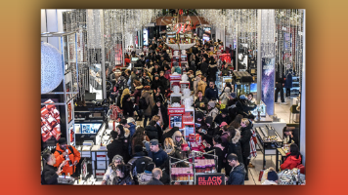
Our dear Heartdweller Family,

Clare just sent me an emergency call. Ezekiel has been having visions and dreams of a synchronized web of bombs planted around many of the shopping malls around the US, all set to go off tomorrow during the Black Friday shopping sales. For those of you listening from other countries, today we celebrated a major holiday, Thanksgiving Day. And tomorrow is a huge shopping day with many sales from the stores. It is traditionally a day when millions of people will be IN these malls shopping for good prices for Christmas.

One of the brothers in the Refuge has also had visions of these bombs going off, and children having to witness the damage, danger and horror of seeing these things happen before their eyes. The children seem to be protected, but they are witnesses of the event.

Mother Anna and I have been praying at night, and the Lord is literally praying around the world during these prayers especially over the past week.

Another of the priests wrote me today and was on high Prayer Alert because of the rhemas he has been receiving as well.

Please join with us as soon as you receive this message and PRAY with us. Offerings, sacrifices, fastings, praying the Mercy Chaplet and Rosaries - this is a time to press in and give to our Lord anything and everything that we can for the sake of this country and our world.

May the Lord richly bless you, dear Heartdwellers. Let us unite our voices strongly for our Lord.

